**Assignment 2**

**Problem Statement**

Set up a virtual machine in Google Cloud Platform (GCP), implement auto-scaling policies based

on workload, and configure security measures like firewall rules and IAM.

**Implementation:**

To perform this task, we need to setup GCP account and login to the google cloud console with

Created account credentials

**Link for GCP Platform:**

https://console.cloud.google.com/

**Creation of Virtual machine**

1. Login to the GCP Console
2. Once Logged in you will see the welcome screen

**Screenshot for reference:**

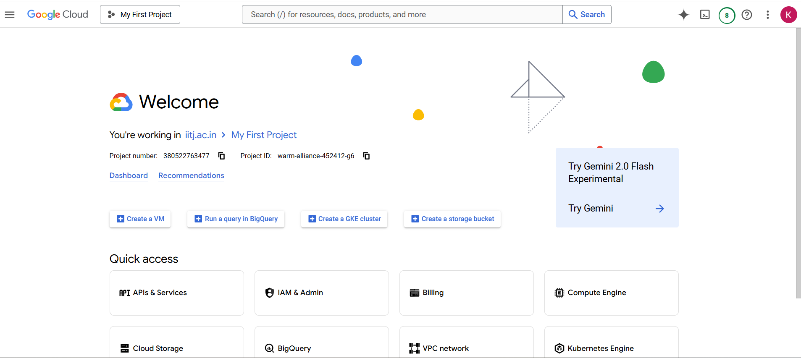

1. On the top left corner, you will see 3 lines known as navigation menu click on it and click on compute engine and click on vm instances

**Screenshot for reference:**

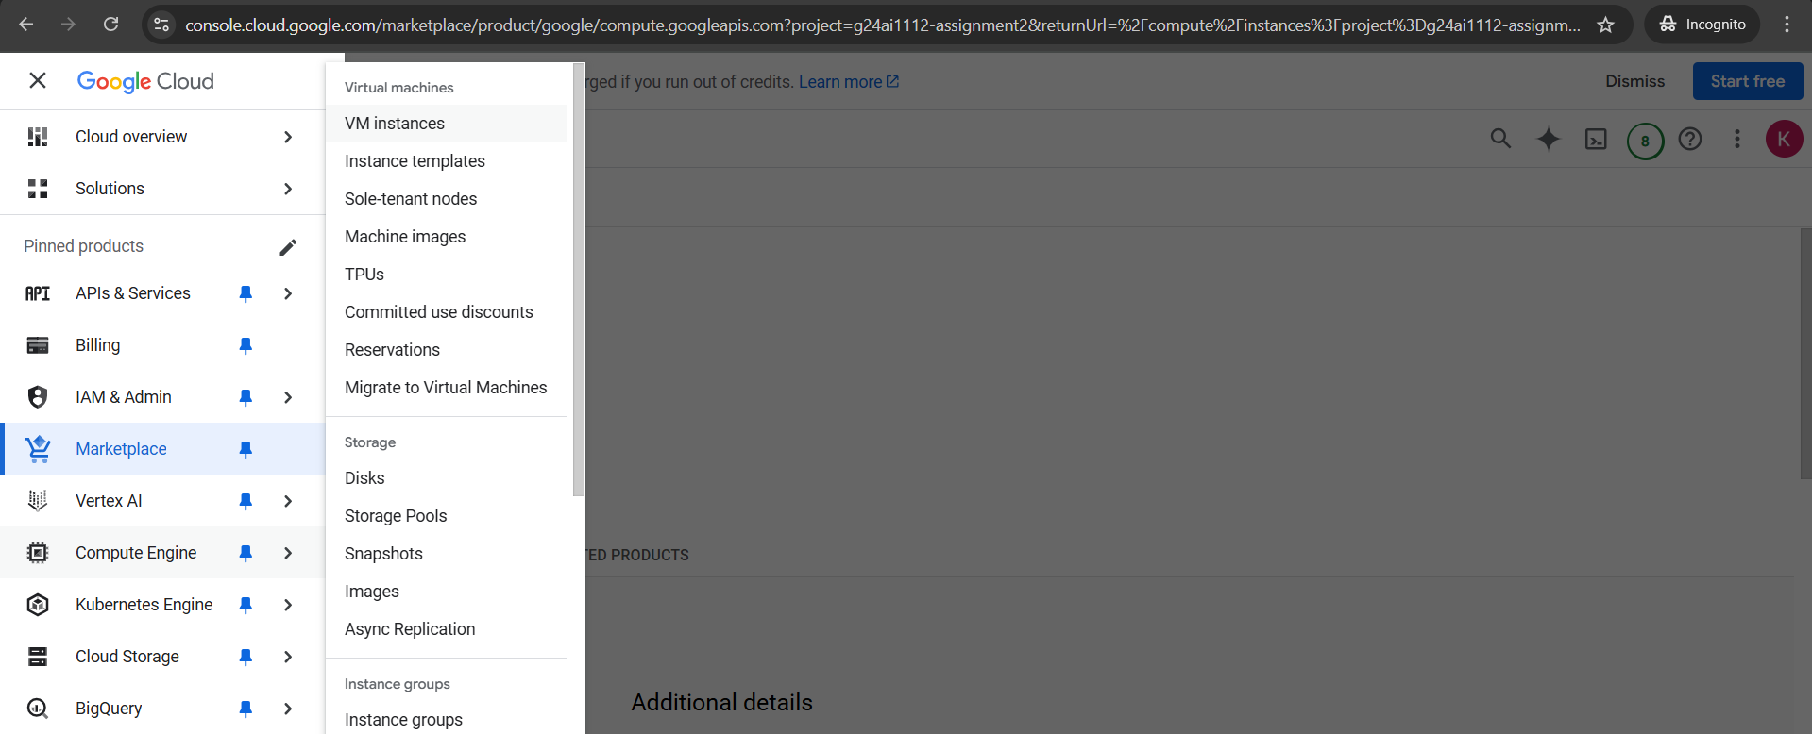

1. Create a new project and click on new project

**Screenshot for reference:**

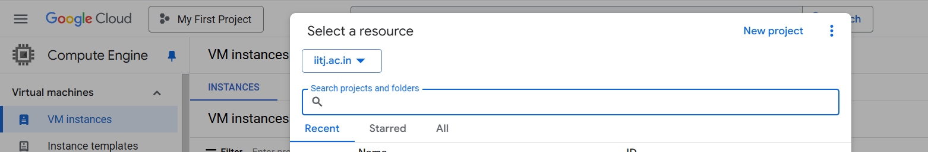

1. Give the details like project name,organization,location and click on create

**Screenshot for reference:**

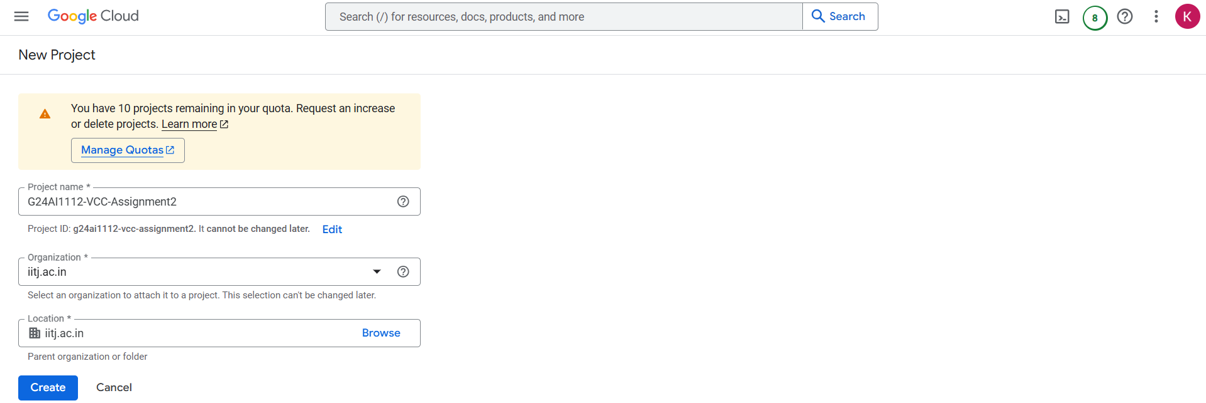

1. Once clicked on create you can see in notifications stating that your project has been created.

**Screenshot for reference:**

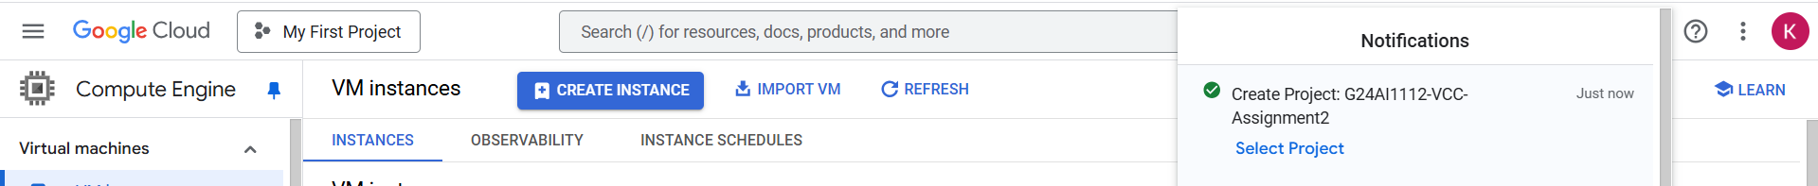

1. Once created you can see the vm instances page

**Screenshot for reference:**

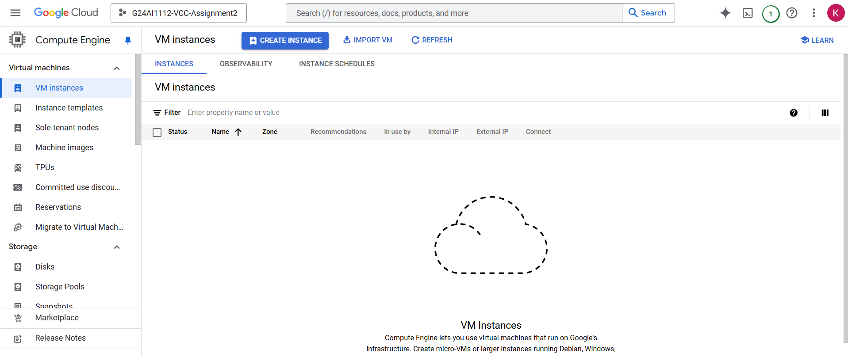

1. Click on create an instance
2. Give the details like name,select the region,zone and select vcpus and its memory for a particular series etc

**Screenshot for reference:**

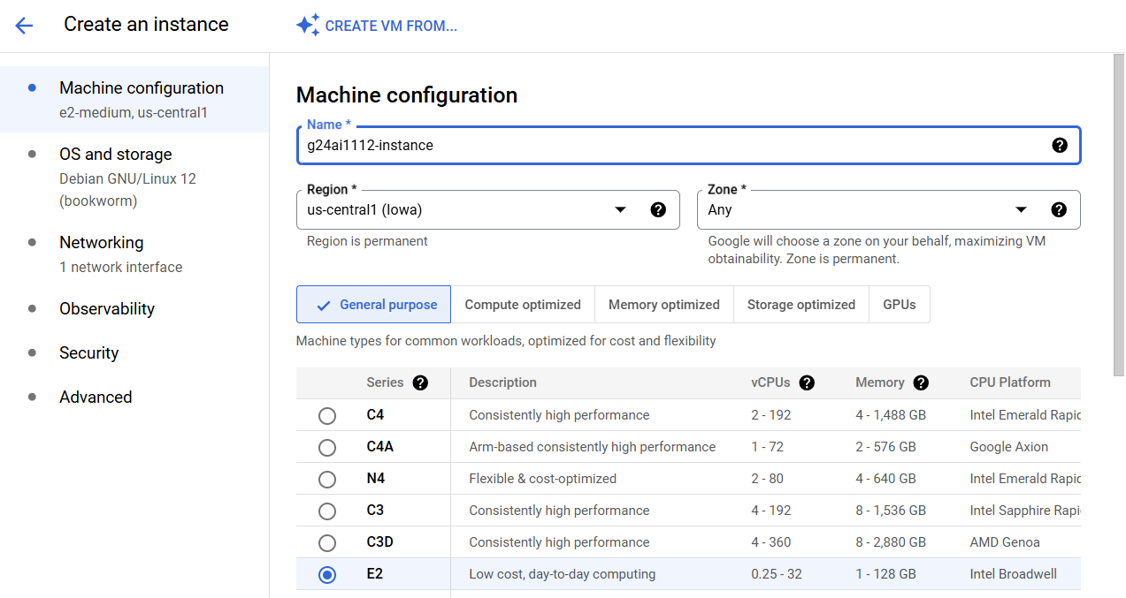

1. Go to OS and Storage and select the OS with which you wanted to create the VM.
2. The default OS Image and details will be provided and the default OS image is Linux but I wanted to go with windows hence click on change

**Screenshot for reference:**

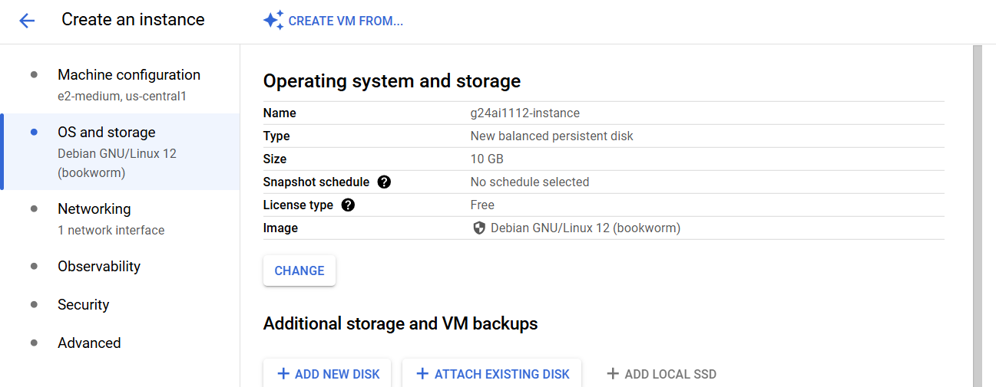

1. Choose the operating system name to windows server,version as windows server 2019 datacenter,boot disk type as balanced persistent disk and size is 50GB and minimum size is 50GB and click on select

**Screenshot for reference:**

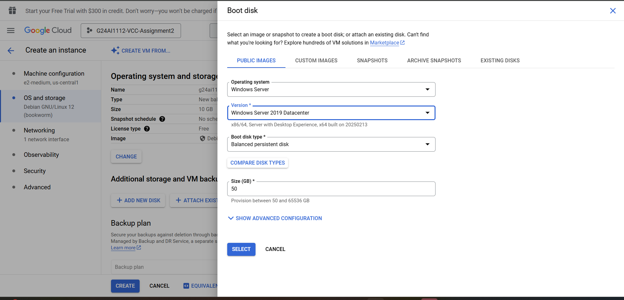

1. Now you will see the options of windows operating system.

**Screenshot for reference:**

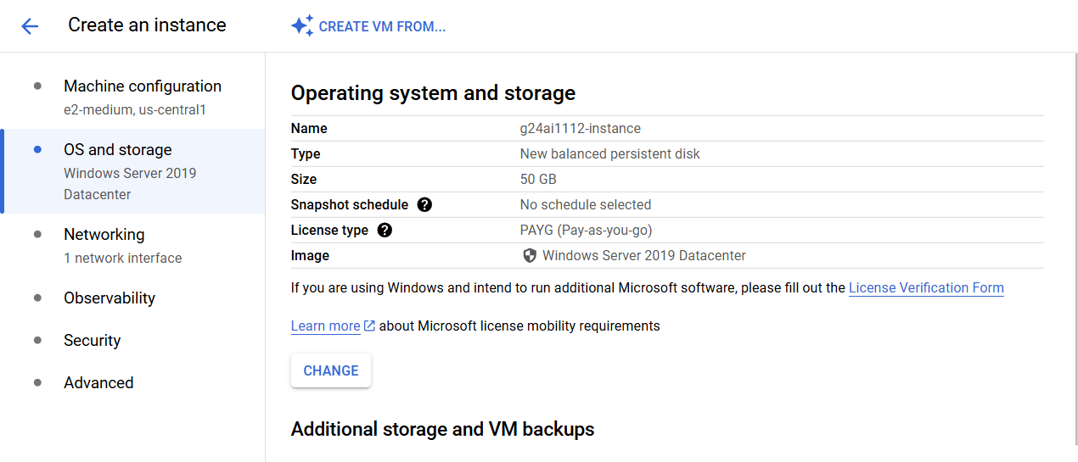

1. In network settings for firewall checkbox for allowing traffic for http,https and load balancer.

**Screenshot for reference:**

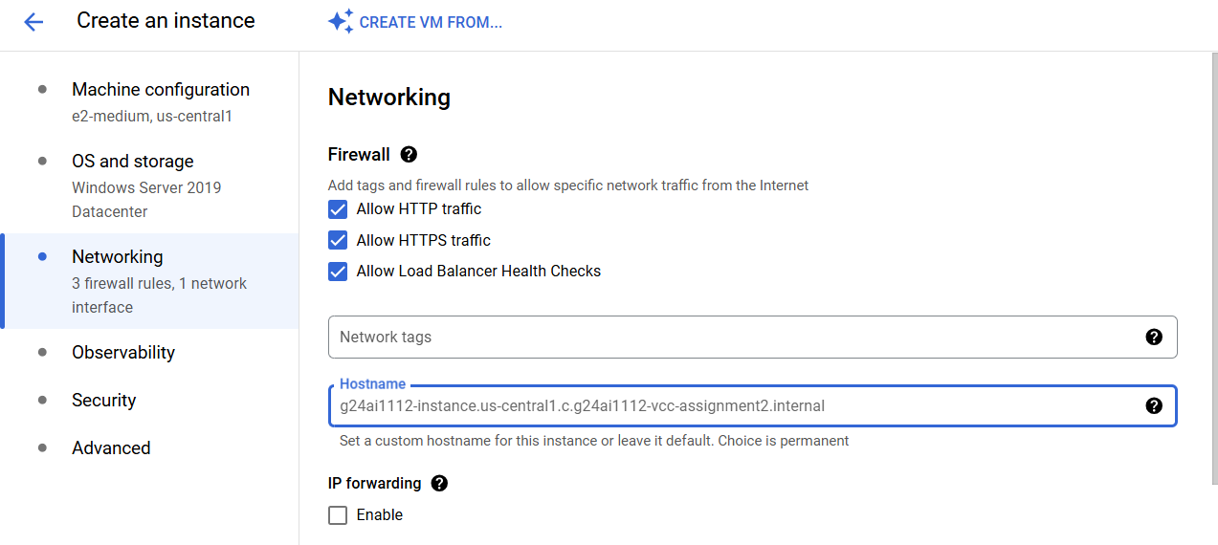

1. Click on Create
2. It takes some time for VM creation and wait for somtime for the complete and successful VM creation

**Screenshot for reference:**

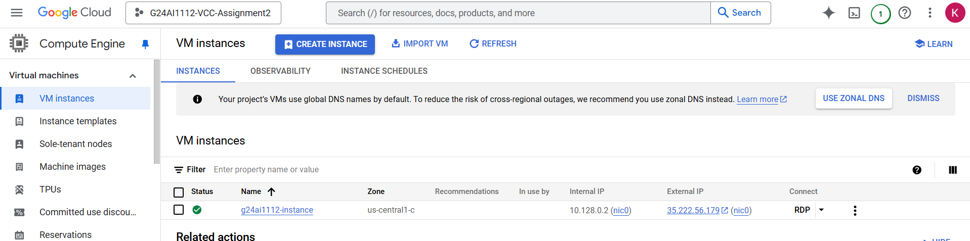

1. As it is windows server we have to connect it using RDP,click on the name of the instance to see the status of it and you can see it the status as running.

**Screenshot for reference:**

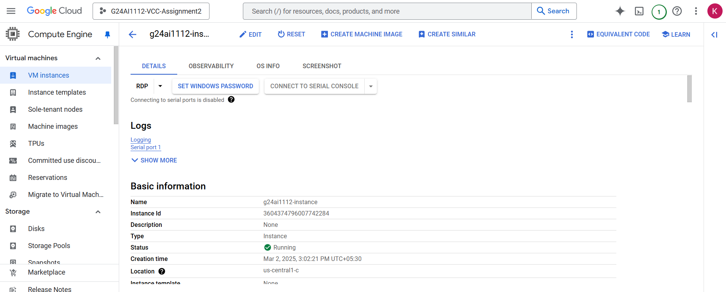

1. Wait for 10 minutes of time as it takes some time to get connected and click on set windows password to download this rdp and to connect to the created vm

**Screenshot for reference:**

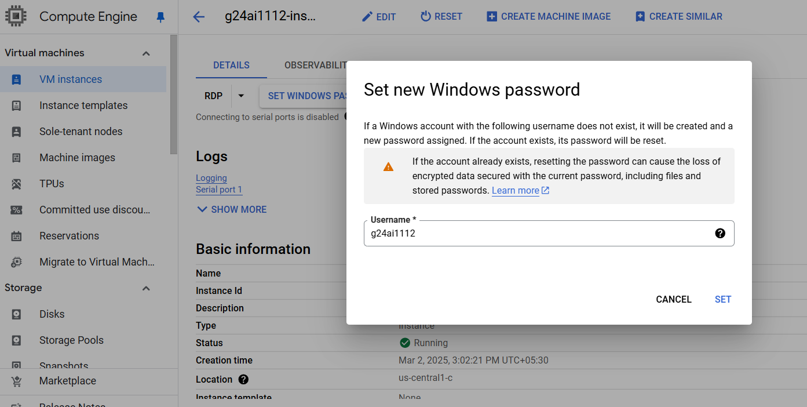

1. It generates the password and copy it as its needed to connect to your VM and click on close

**Screenshot for reference:**

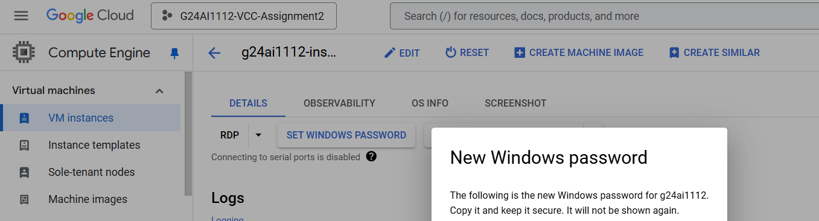

1. Click on the RDP and click on the download the RDP file and download the RDP file

**Screenshot for reference:**

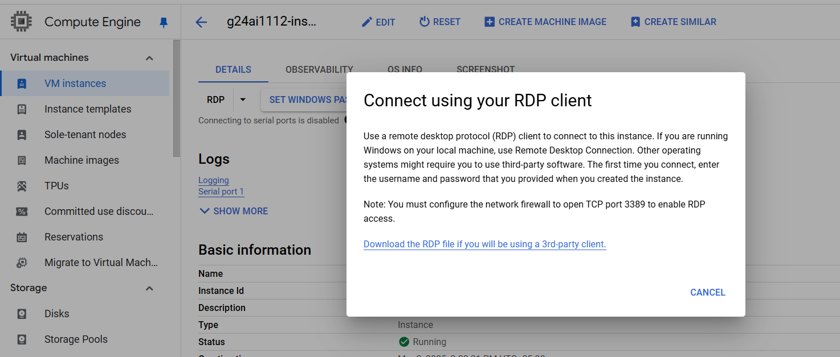

1. It will download the RDP file and once downloaded double click on it and click on connect

**Screenshot for reference:**

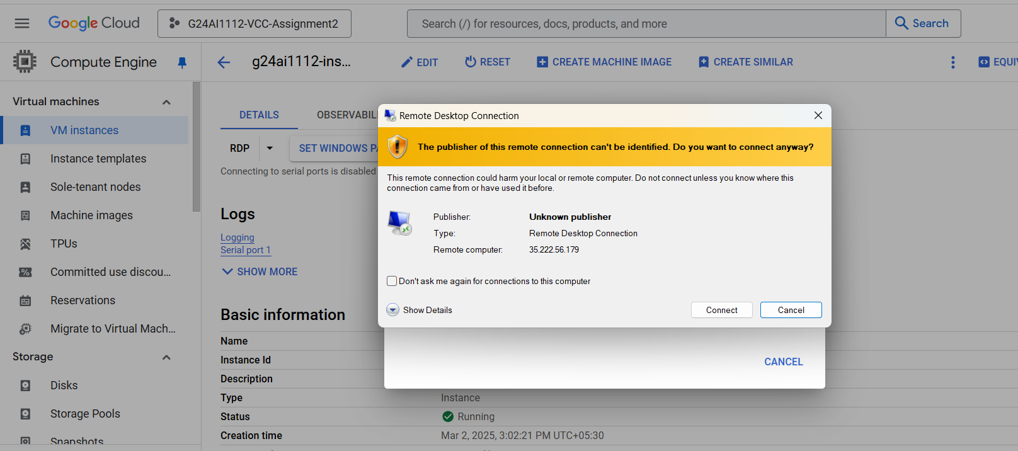

1. Give the password which you have setup for it to connect for the VM and click on ok

**Screenshot for reference:**

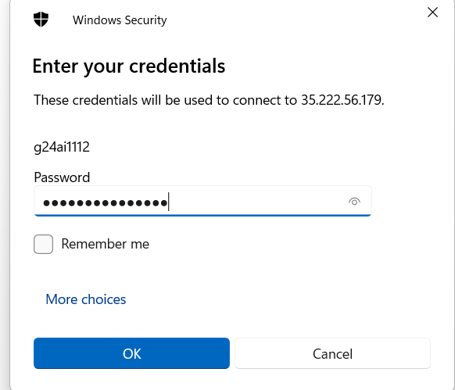

1. Click on yes for the dialogue box of computer to be verified

**Screenshot for reference:**

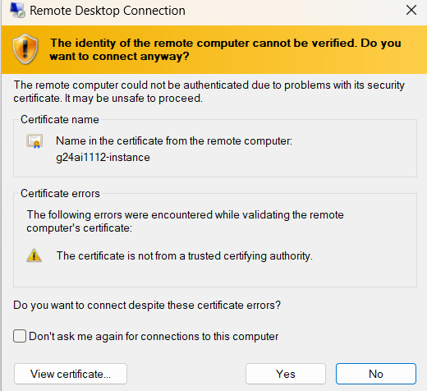

1. You can see the instance after this.

**Screenshot for reference:**

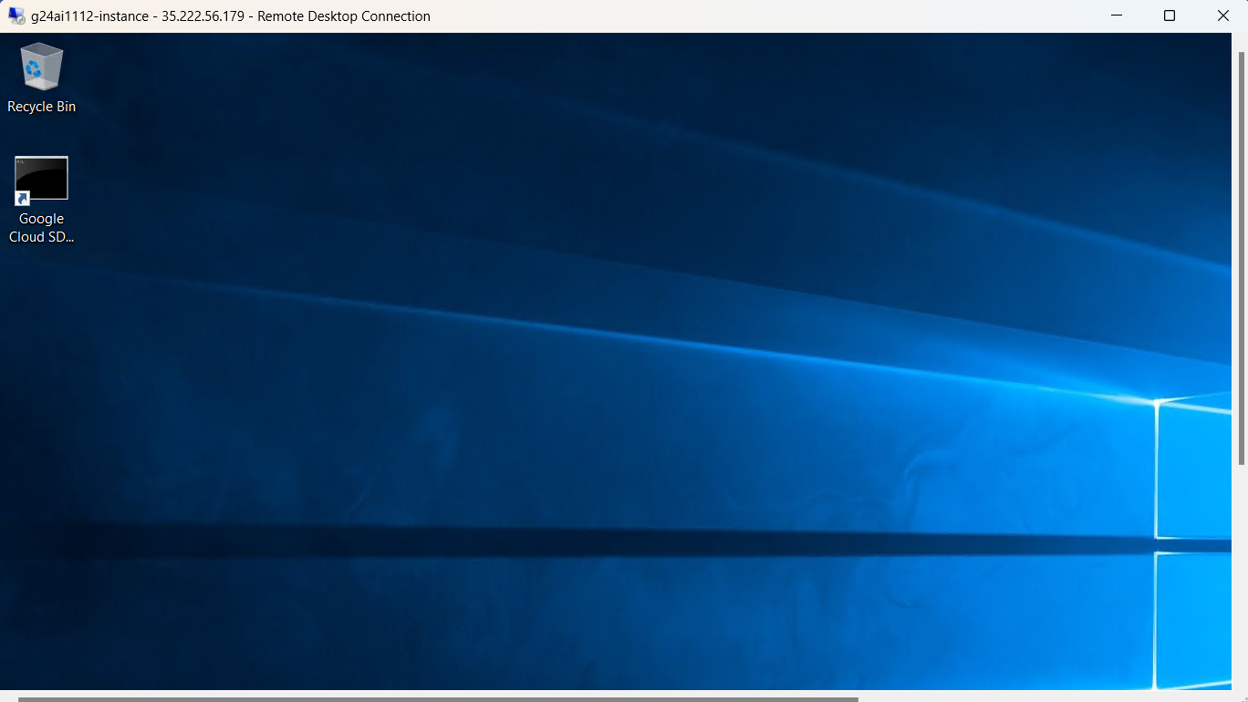

**Implementation of Auto Scaling Policies**

Implementation of Auto Scaling Policies can be done using Managed Instance Group

**Steps for creating Managed Instance Group**

1. Go to the Instance groups page.

**Screenshot for reference:**

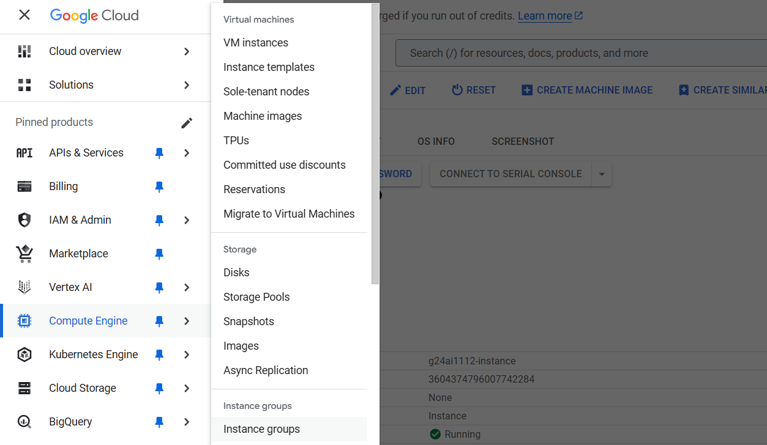

1. Click on "Create instance group".

**Screenshot for reference:**

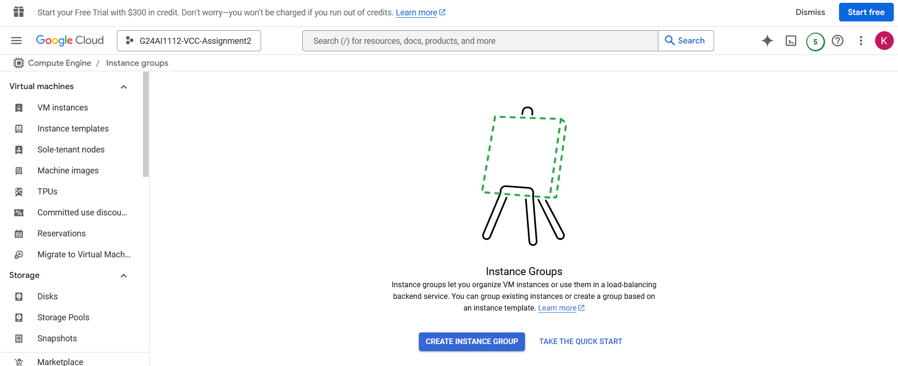

1. Choose "Managed instance group give the details and in the instance template click on create new instance template,and choose the options to the similar way you created for windows vm and click on save and continue

**Screenshots for reference:**

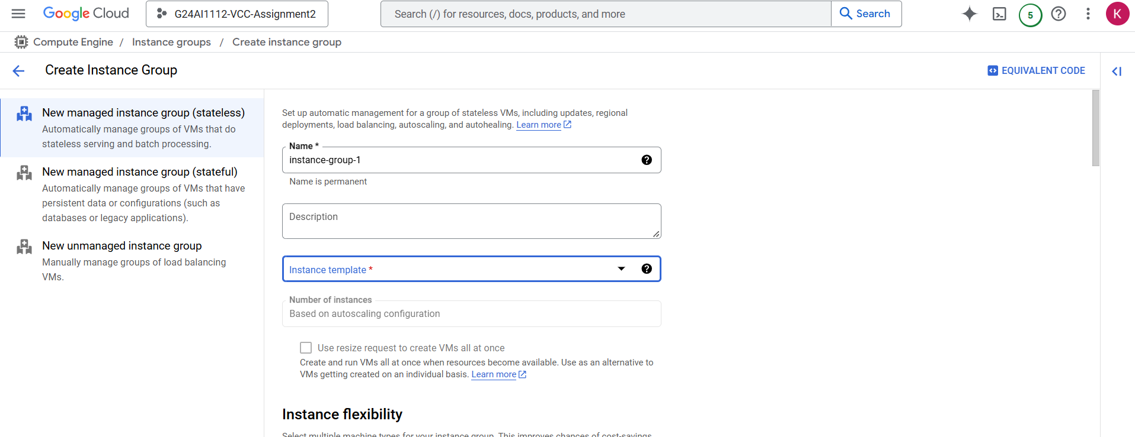

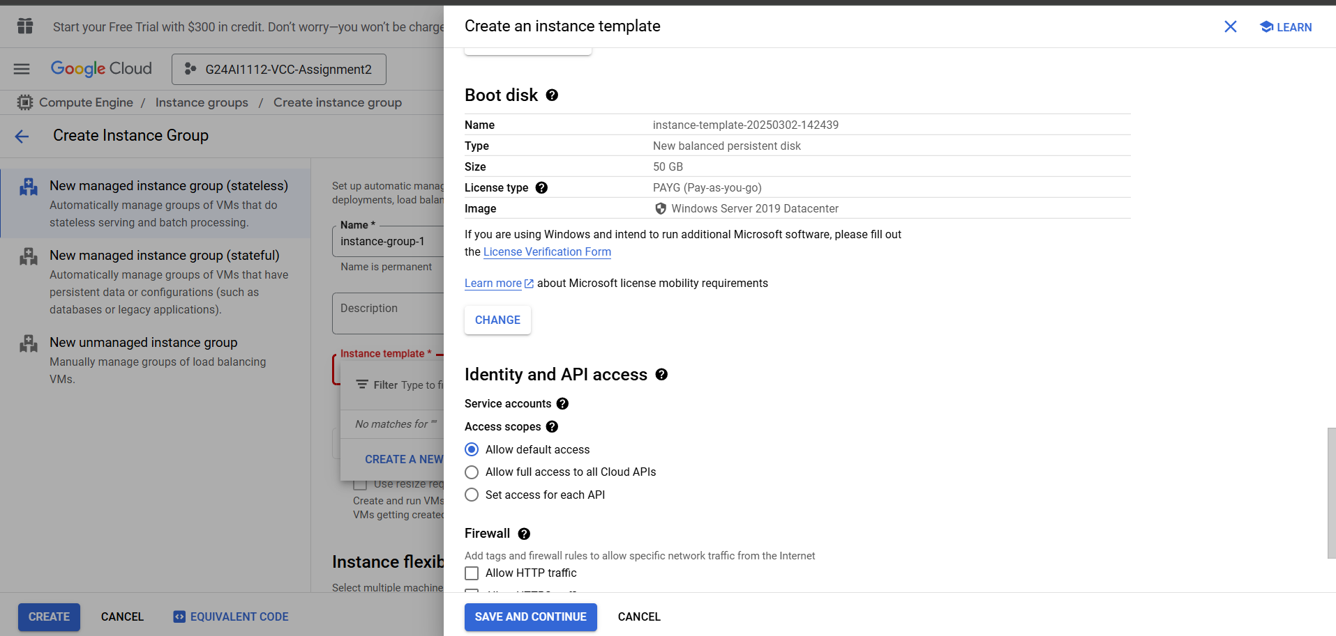

1. In auto scaling options give minimum 2 and maximum number of instances as 4 and CPU utilization as 60% and mention the details for vm instance life cycle for action on failure and auto healing for health check

**Screenshots for reference:**

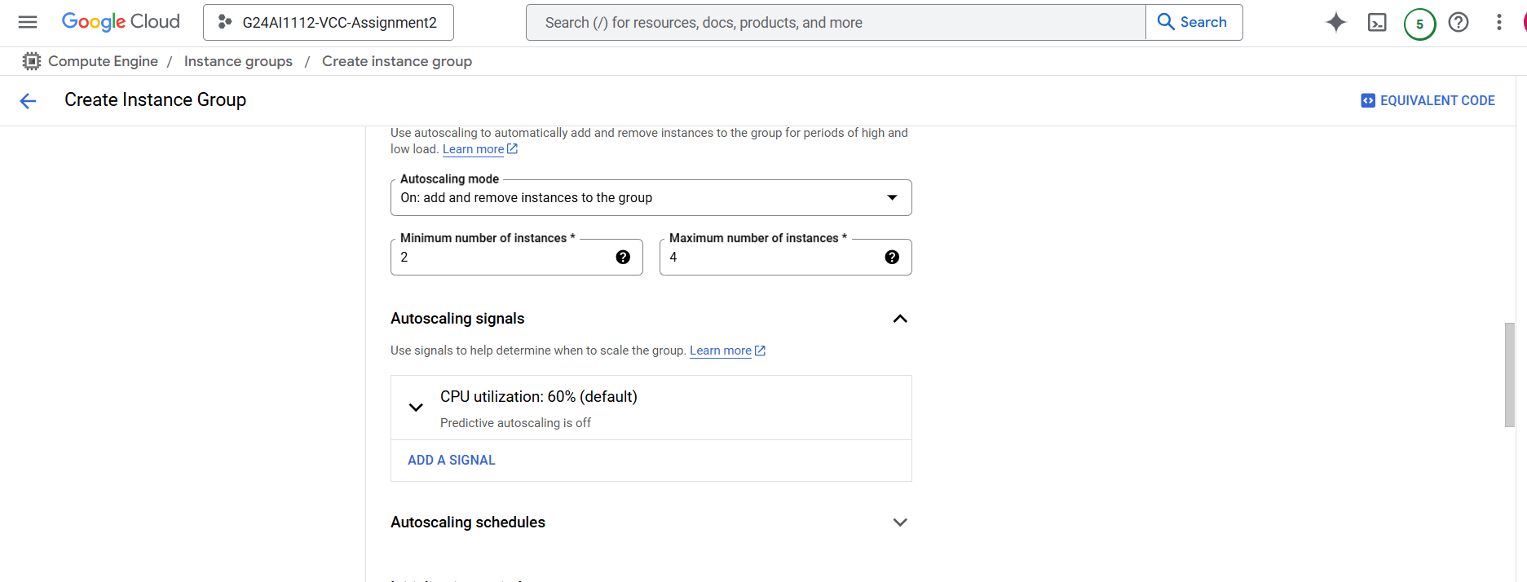



1. Click on create

**Screenshot for reference:**

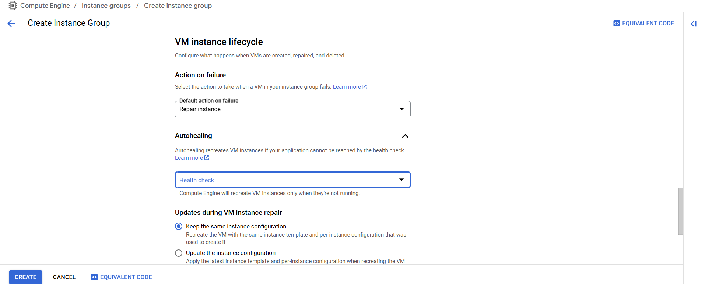

1. Now you can see the instance groups created.

**Screenshot for reference:**

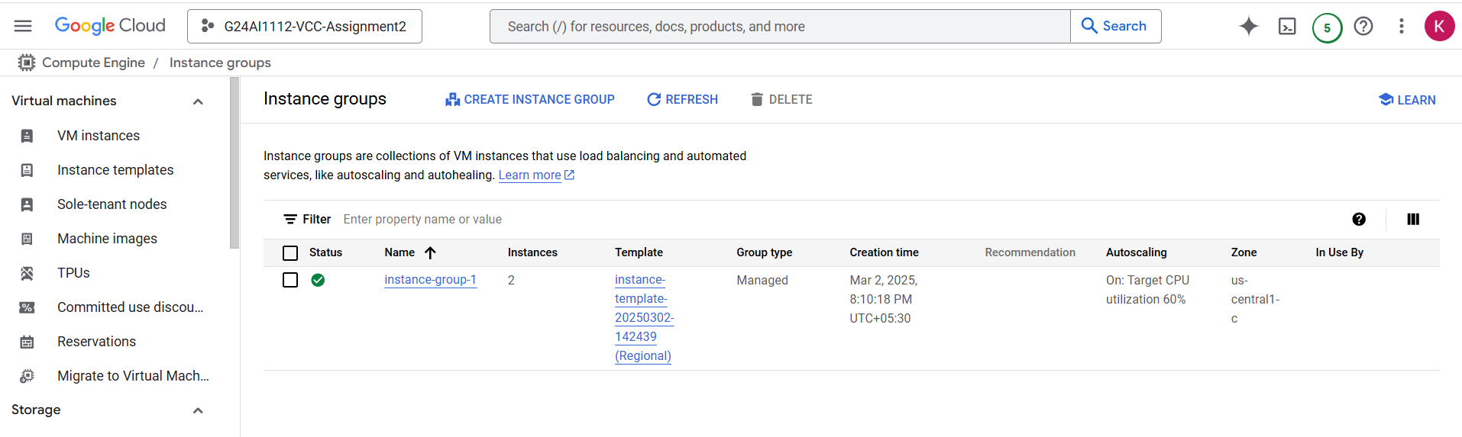

1. Click on instancegroup-1 to see the no of instances present

**Screenshot for reference:**

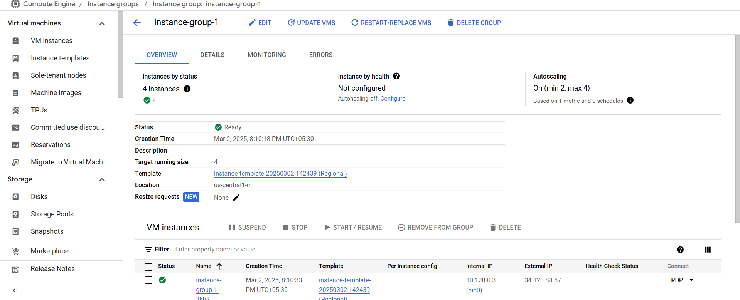

1. You can see the 4 instances created as we have selected maximum as 4

**Screenshot for reference:**

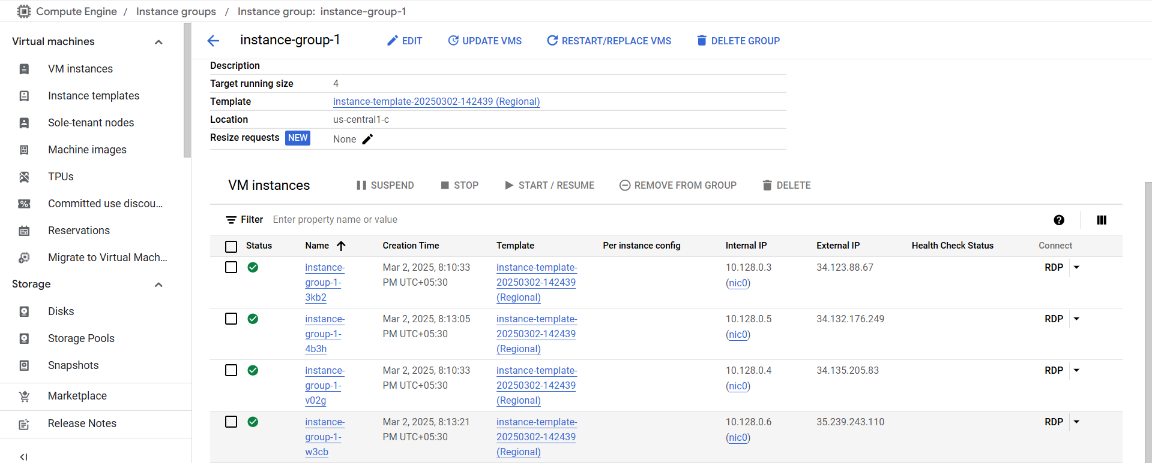

1. To check for the auto scaling is implemented or not delete one instance and after that it creates automatically another instance
2. Select last instance and click on delete

**Screenshot for reference:**

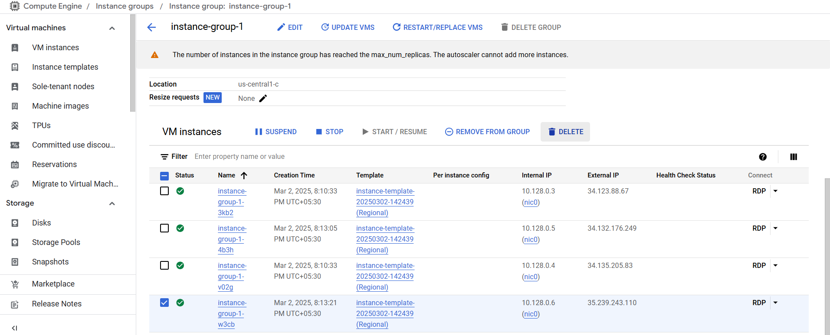

1. Confirm to delete and click on delete

**Screenshot for reference:**

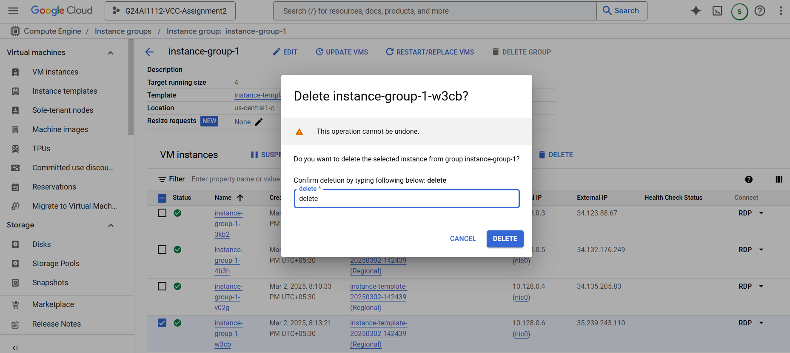

1. As soon as its deleted it creates another instance automatically

**Screenshots for reference:**

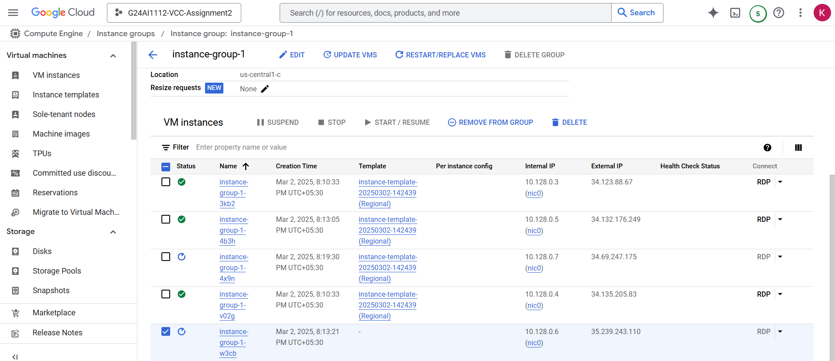

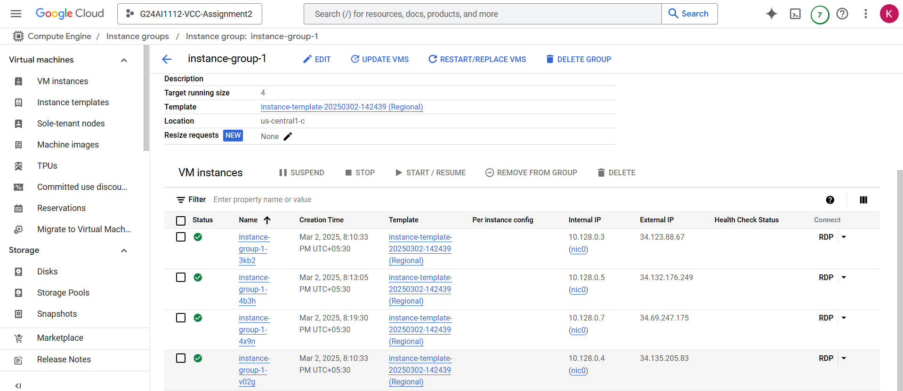

**Justification of implementation of Auto Scaling:**

When the instance is deleted without recreating by ourself manually it has automatically created it means it has automatically scaled up the instances as per the configurations and the work load that has been set.

**Configuring Security Measures**

Security measures can be implemented by setting up by firewall and IAM Policies

**IAM Policies:**

1. Go to IAM & Admin and click on IAM

**Screenshot for reference:**

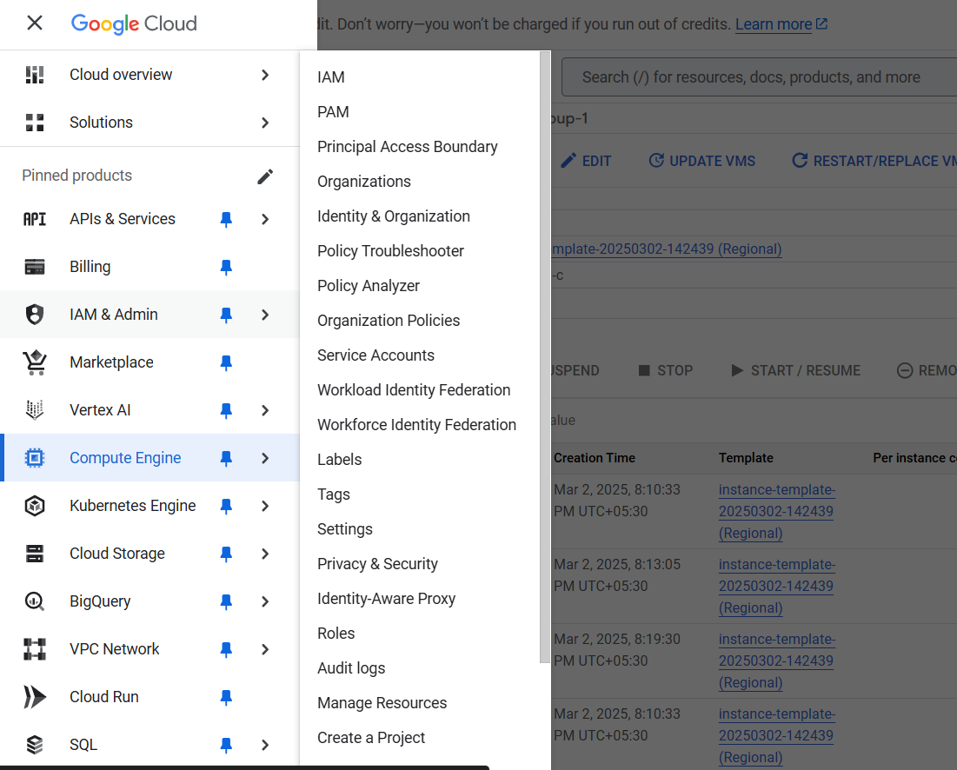

1. You will see the users present in it

**Screenshot for reference:**

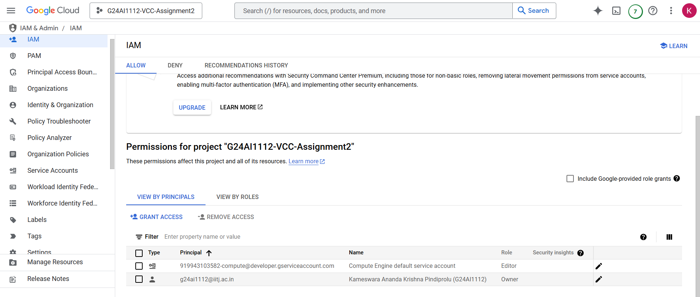

1. Click on grant access to add new user and give the role, in new principle give your email of any eg like personal email and role as viewer and click on save

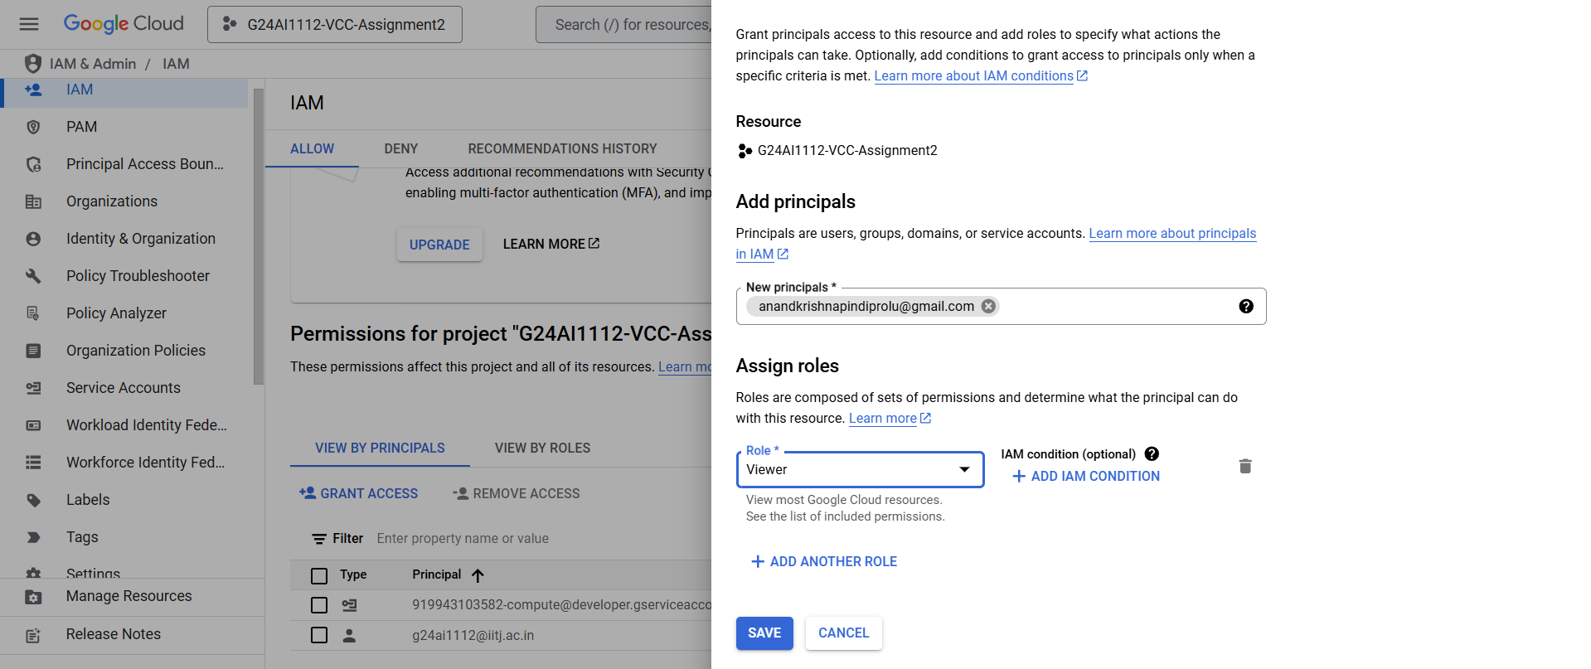

1. You can see the user granted access with viewer role

**Screenshot for reference:**

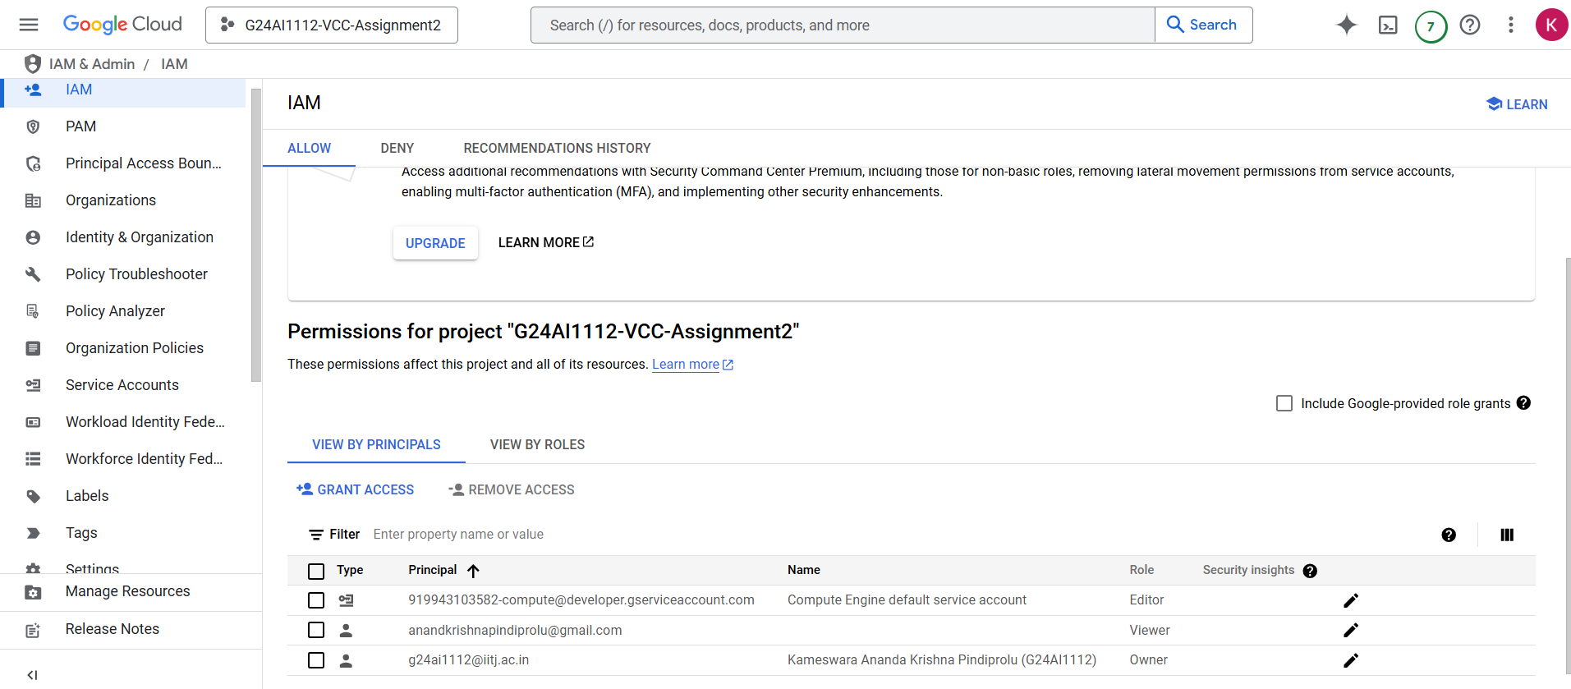

**Implementation of Firewall**

1. Go to the VPC network in the menu and click on firewall

**Screenshot for reference:**

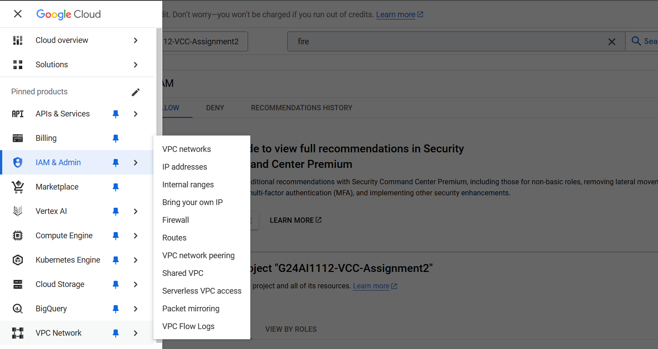

1. Once clicked entered you can see the default firewalls that are created already

**Screenshot for reference:**

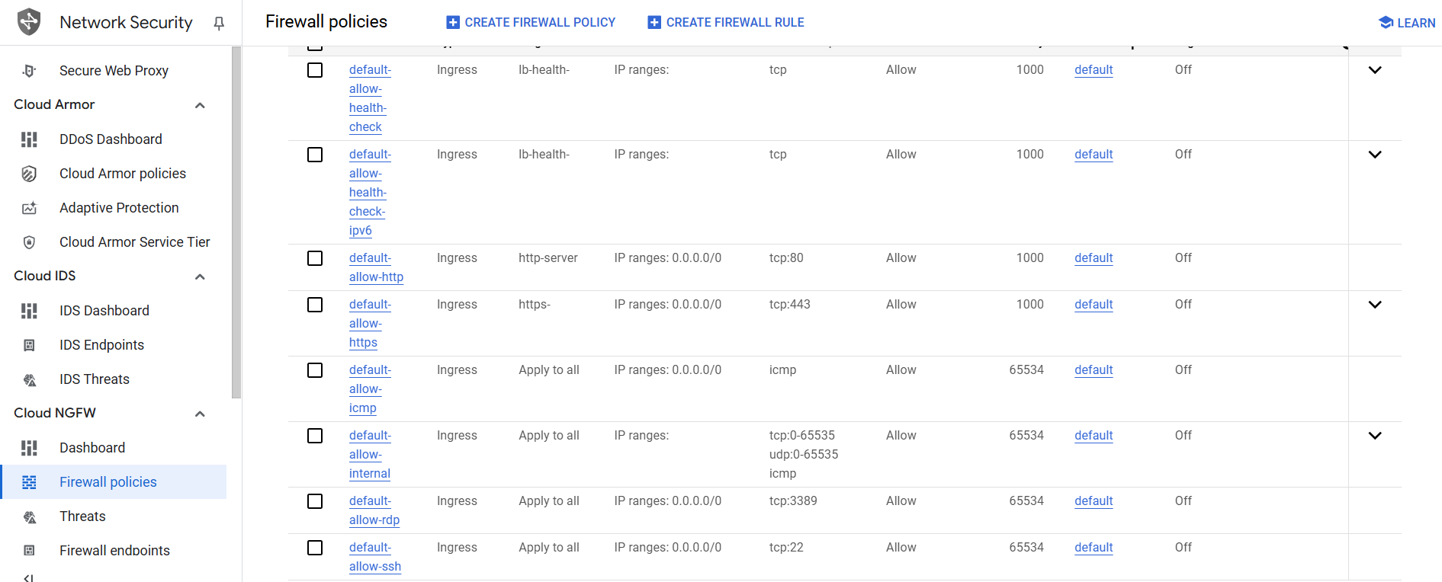

1. Click on Create firewall rule to add new firewall and give the details and click on create

**Screenshots for reference:**

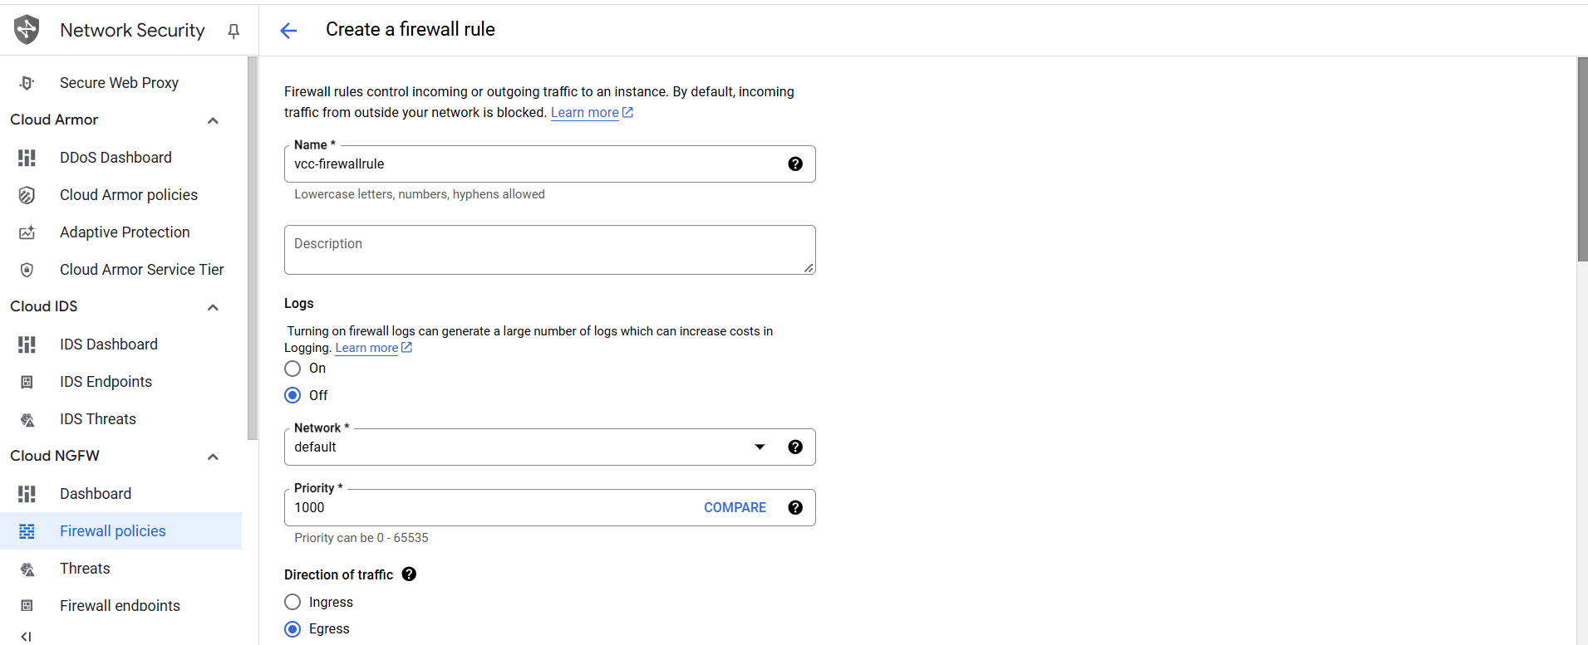

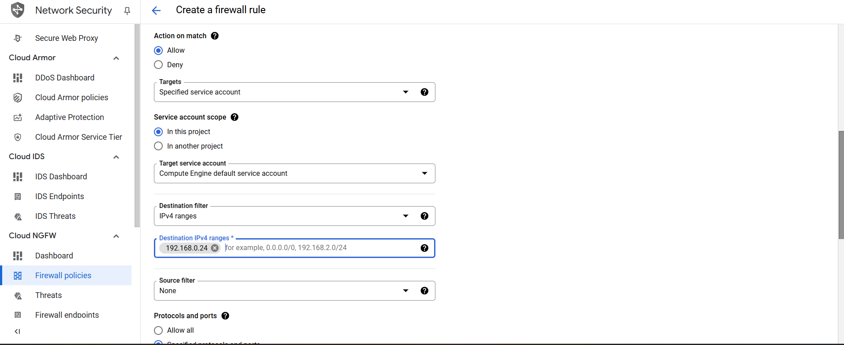

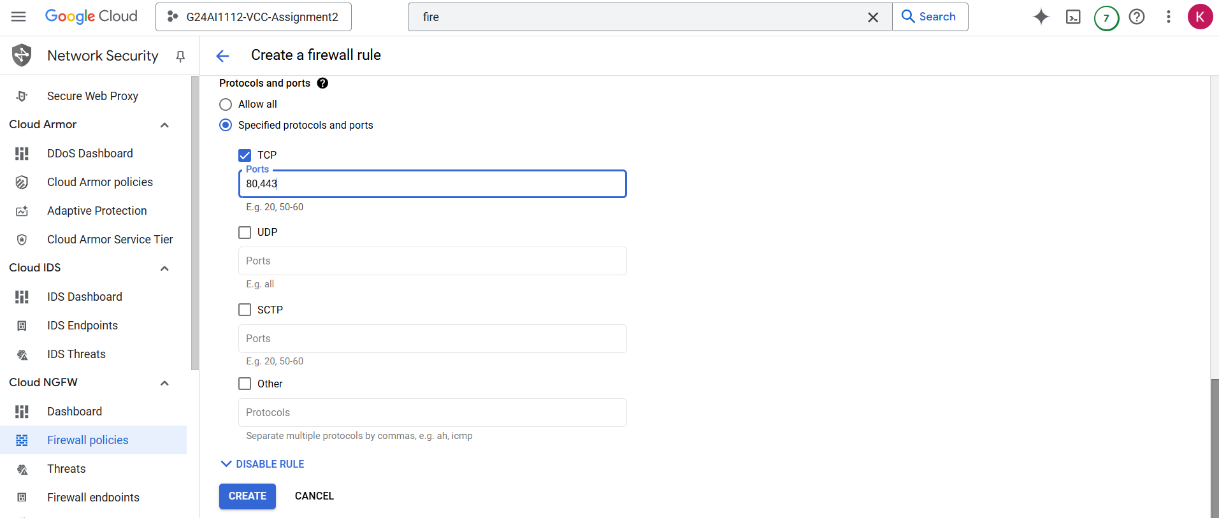

1. You will see the created firewall rule in the list.

**Screenshot for reference:**

